GARAGE MANAGEMENT SYSTEM

College Name : KPR College of Arts Science and Research College Code : bruAz

TEAM ID : NM2025TMID21433

TEAM MEMBERS : 4

TeamLeader: MOULESWARAN B

Email : [23bit032@kprcas.ac.in](mailto:23bit032@kprcas.ac.in)

Team Member : KARTEEBAN S

Email : [23bit019@kprcas.ac.in](mailto:23bit019@kprcas.ac.in)

Team Member : RAJESHKUMAR P

Email : [23bit045@kprcas.ac.in](mailto:23bit045@kprcas.ac.in)

Team Member : RAGHURAM S

Email : [23bit044@kprcas.ac.in](mailto:23bit044@kprcas.ac.in)

# INTRODUCTION

**Project Overview**

The Garage Management System is a valuable tool for automotive repair facilities, helping them deliver top-notch service, increase operational efficiency, and build lasting customer relationships. With its user-friendly interface and powerful features, GMS empowers garages to thrive in a competitive market while ensuring a seamless and satisfying experience for both customers and staff.

By integrating essential functions—such as **Customer details,Appointment scheduling, Service records, and Billing details and feedback**—GMS enables garages to run more smoothly and effectively. Its user-friendly interface allows both staff and customers to

interact with the system effortlessly, reducing errors and saving valuable time. Beyond day- to-day operations, GMS also helps garages foster stronger customer loyalty through timely updates, accurate service records, and personalized communication.

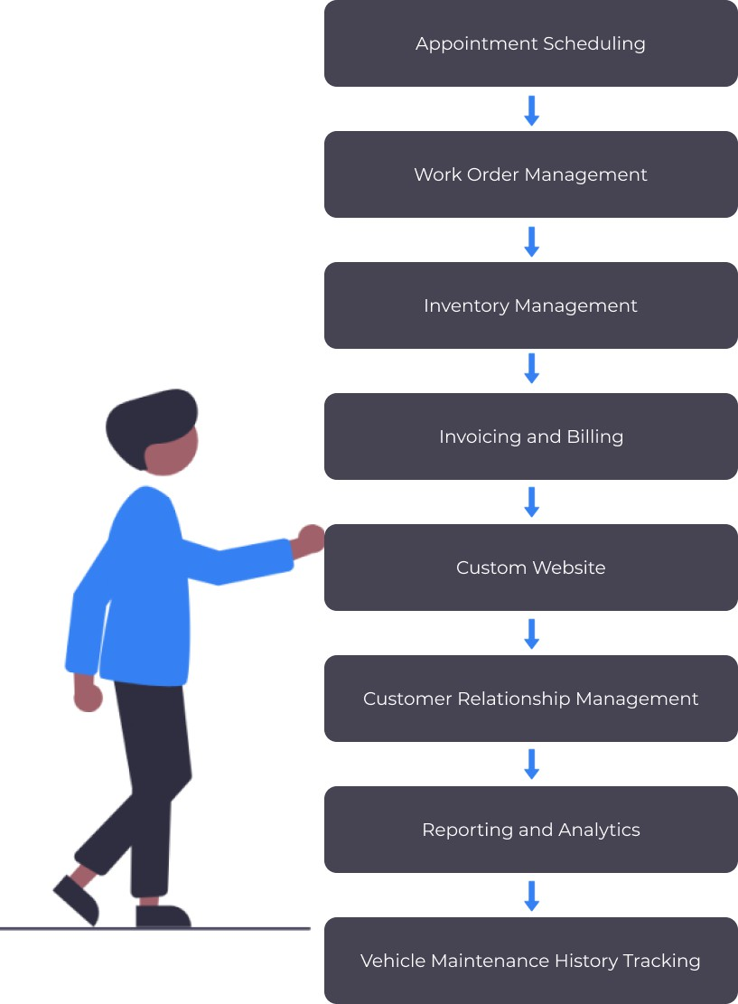

**Purpose**

The primary purpose of the Garage Management System is to provide an all-in-one platform that simplifies and optimizes the operations of automotive repair facilities.

Specifically, it aims to:

1. **Enhance Operational Efficiency** – Automating routine tasks such as job assignment, invoicing, and inventory management to save time and reduce human errors.
2. **Improve Customer Experience** – Offering customers a seamless experience through features like online booking, service reminders, and transparent updates on repair progress.
3. **Strengthen Business Growth** – Equipping garage owners with data-driven insights to make informed decisions, improve profitability, and maintain a competitive edge.
4. **Foster Stronger Relationships** – Building long-term customer trust and loyalty by ensuring reliable service, clear communication, and accessible service history.

**Core Features**

### Customer Details:

Stores comprehensive customer information, including contact details, vehicle history, and preferences, creating a central customer database.

### Appointment Scheduling:

Facilitates appointment management by allowing staff to schedule services, manage technician availability, and send notifications to customers.

### Service Records:

Maintains detailed records of all vehicle services performed, including parts used, labor costs, and service dates, providing a complete history for each vehicle.

### Billing Details:

Manages the financial aspects of services, generating invoices, processing payments, and tracking financial transactions within the shop.

### Feedback Capture:

Provides mechanisms for collecting customer feedback online or through integrated tools, which helps in monitoring service quality and making improvements.

# DEVELOPMENT PHASE

### Creating Developer Account:

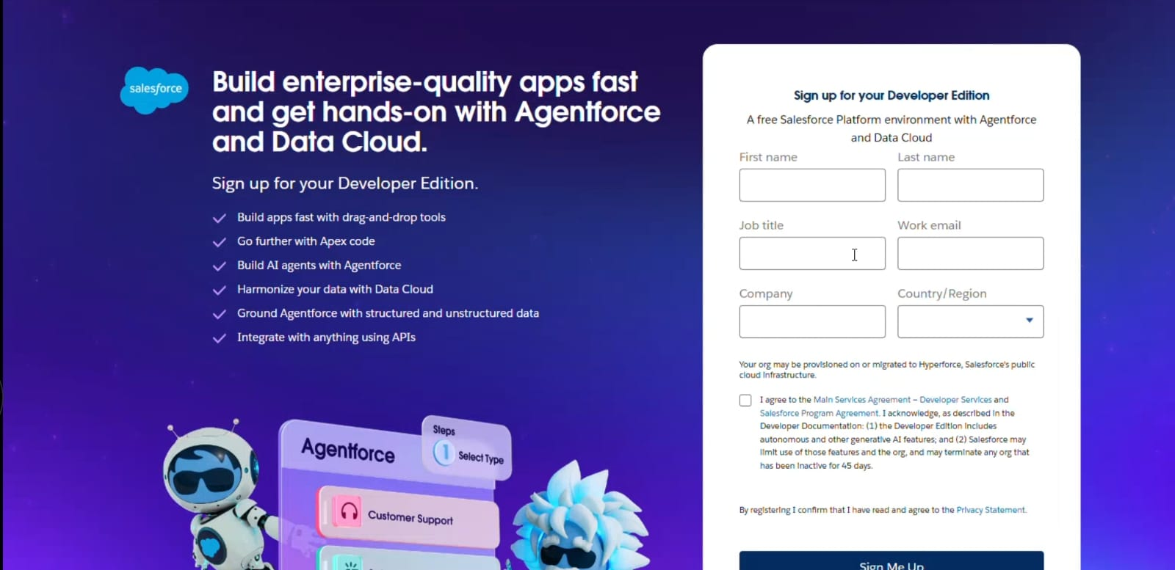

* Created objects : Customer Details, Appointment, Service Records, Billing Details and Feedback

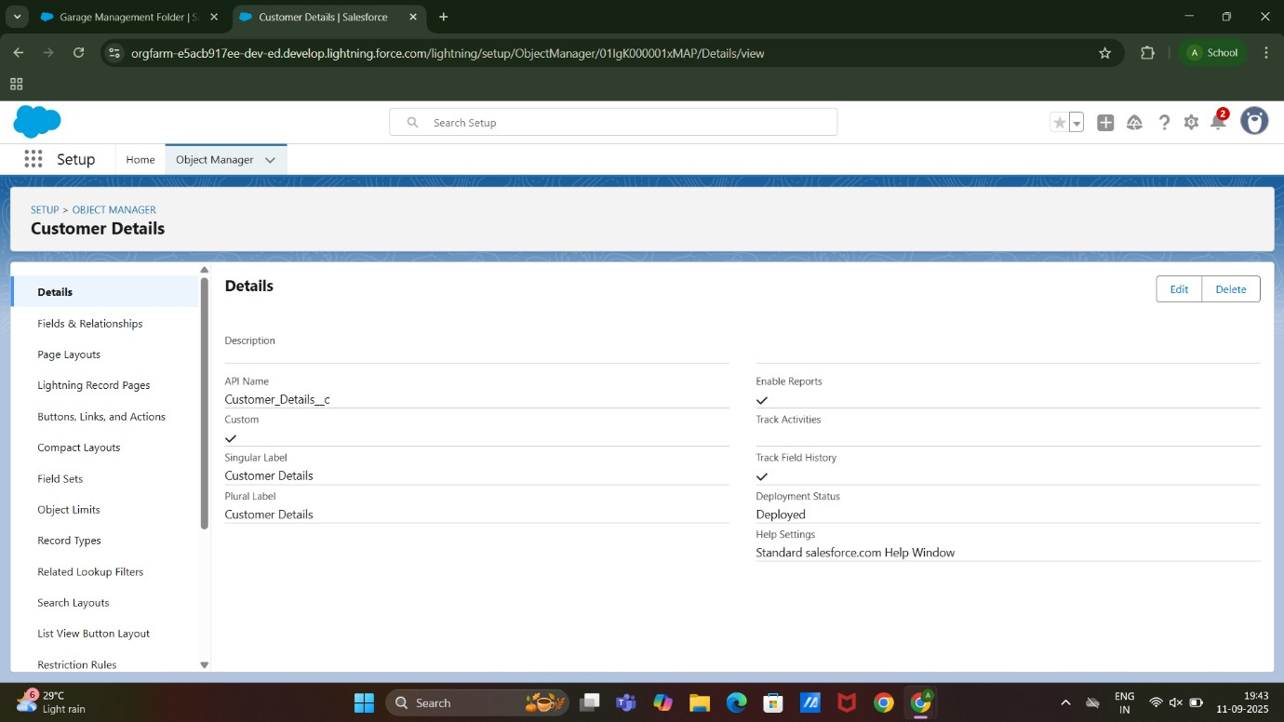

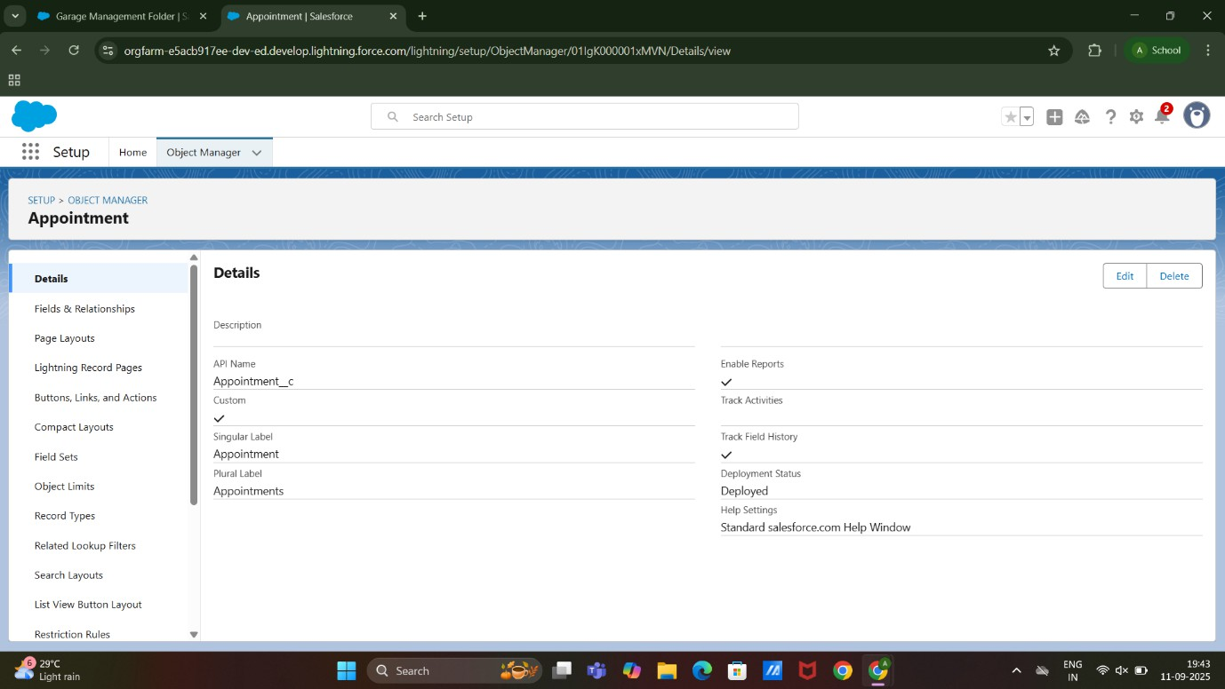

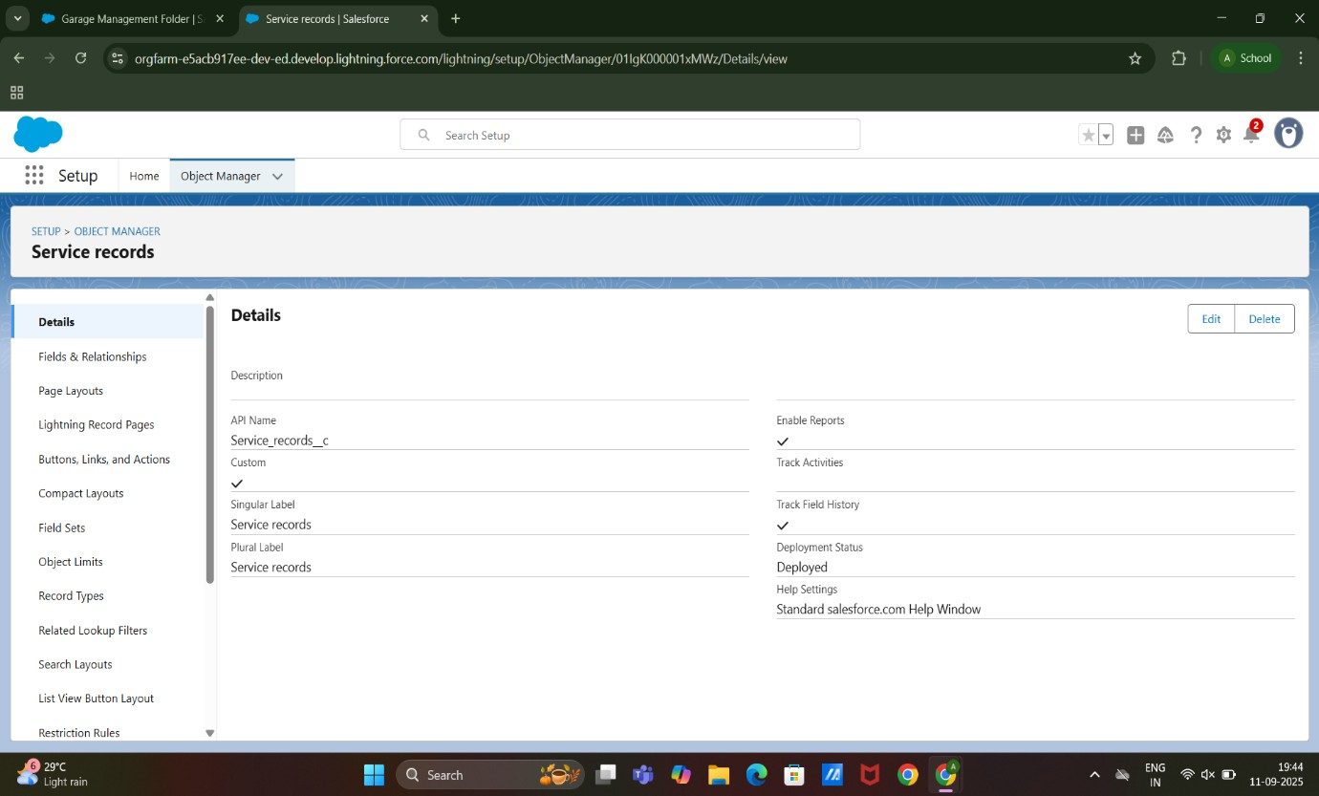

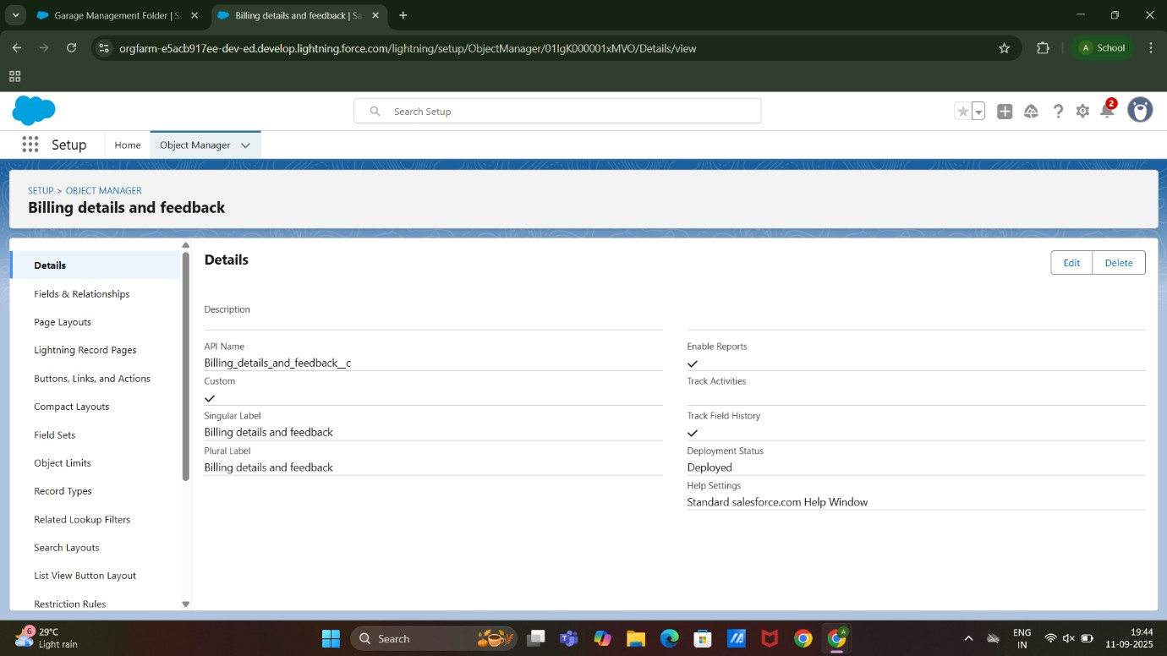

* Created Tabs : Custom Tab and Remaining Tabs(Appointments, Service records,Billing details and feedback)

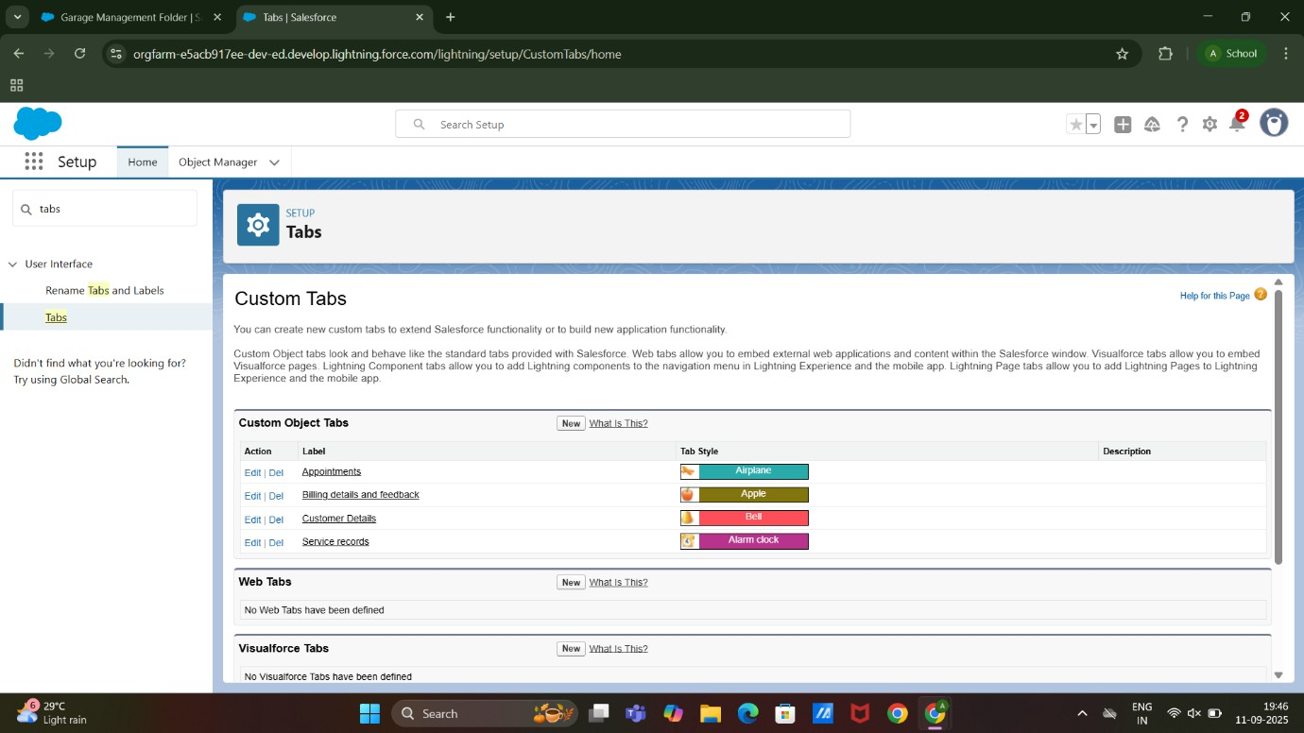

* Created a Lightning App:

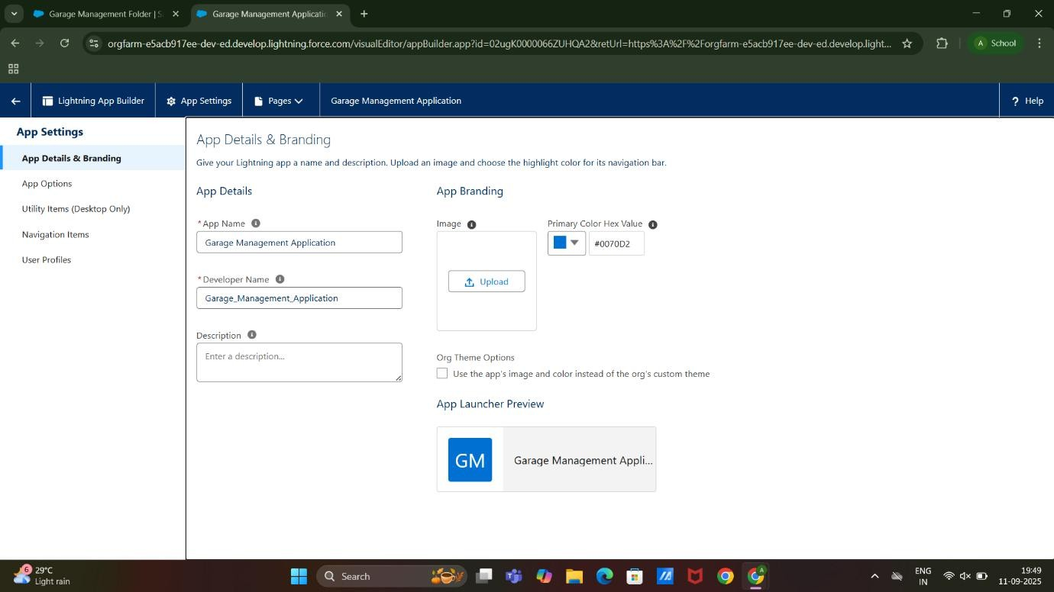

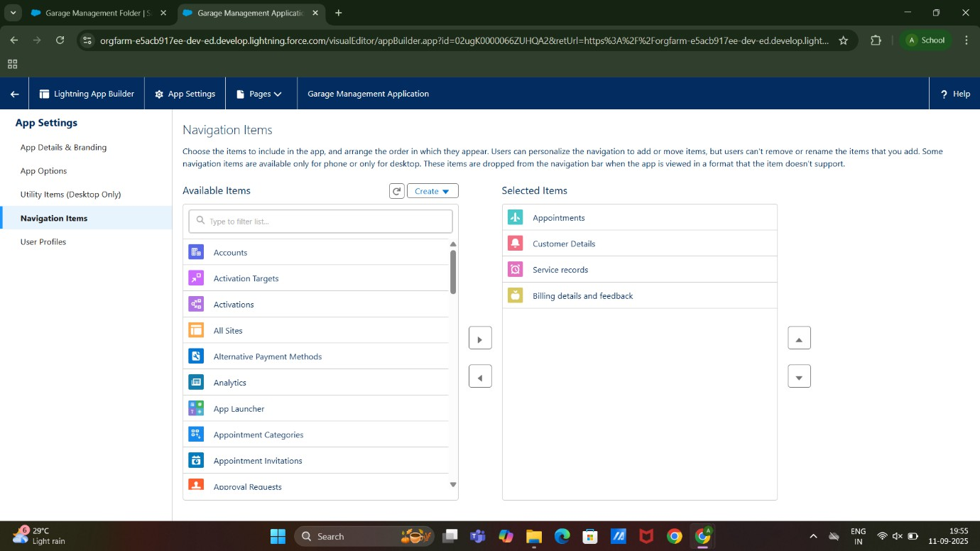

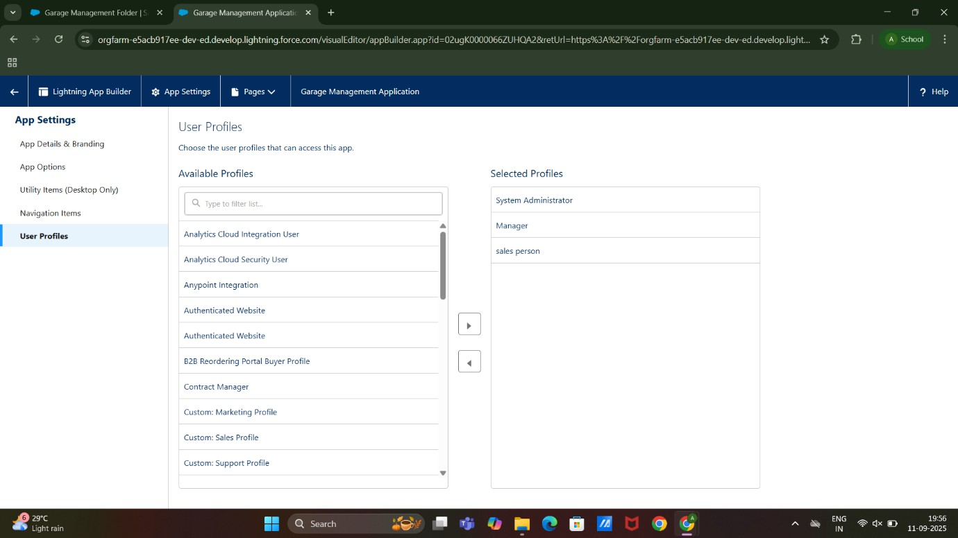

* Created a Fileds : For Customer Details Object, Lookup, Checkbox, Date, Currency, Text, Picklist and Formula Field in Service records Object

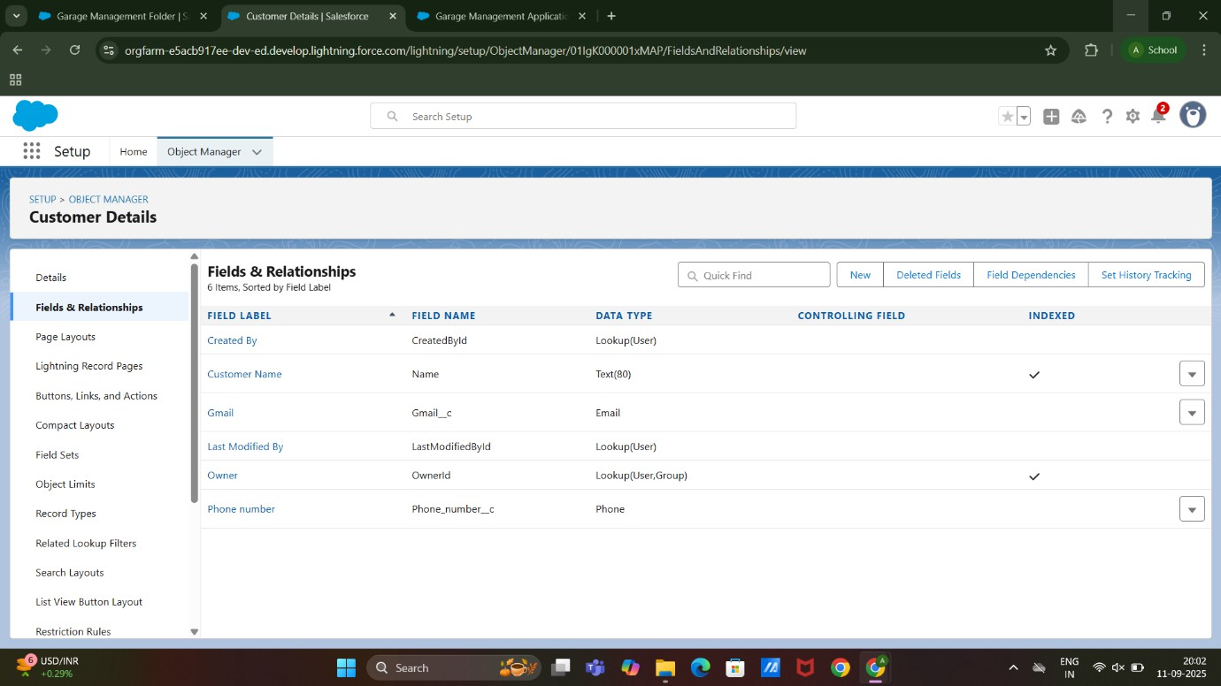

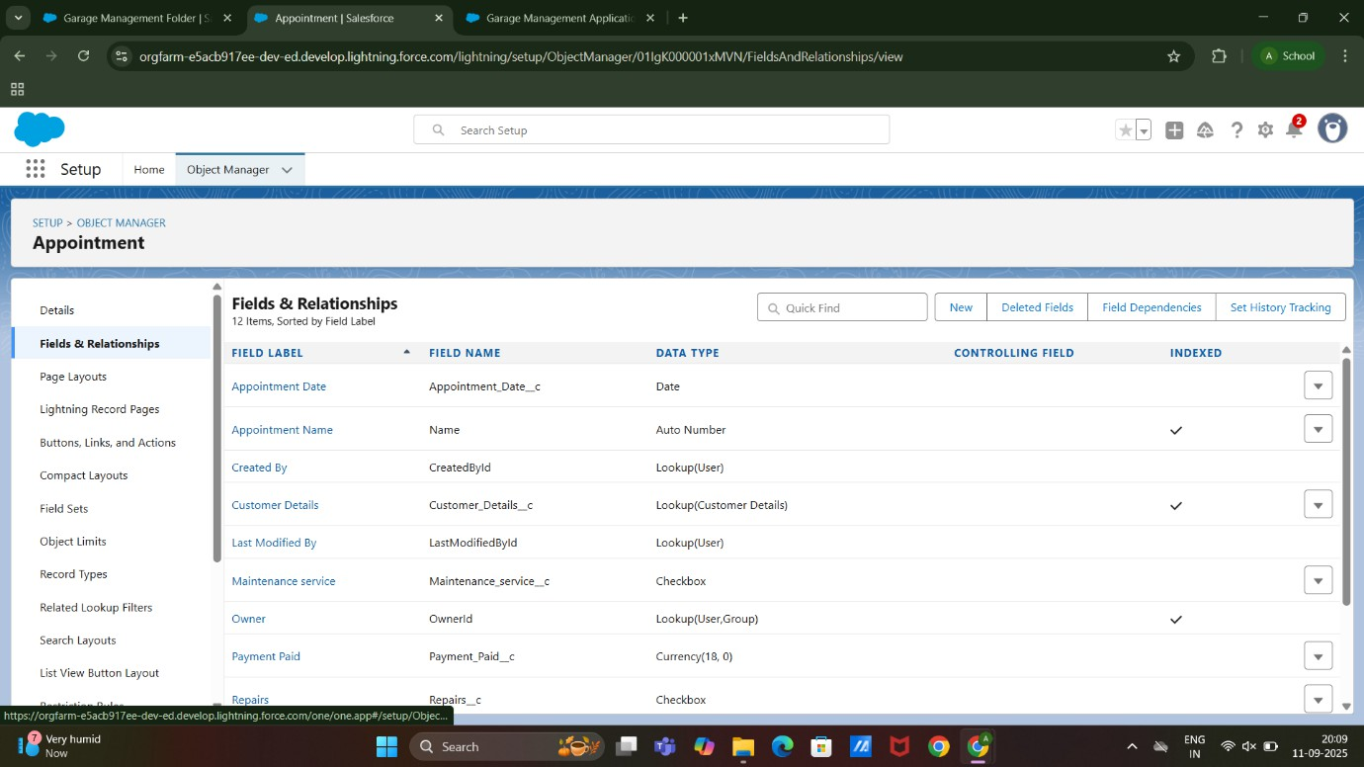

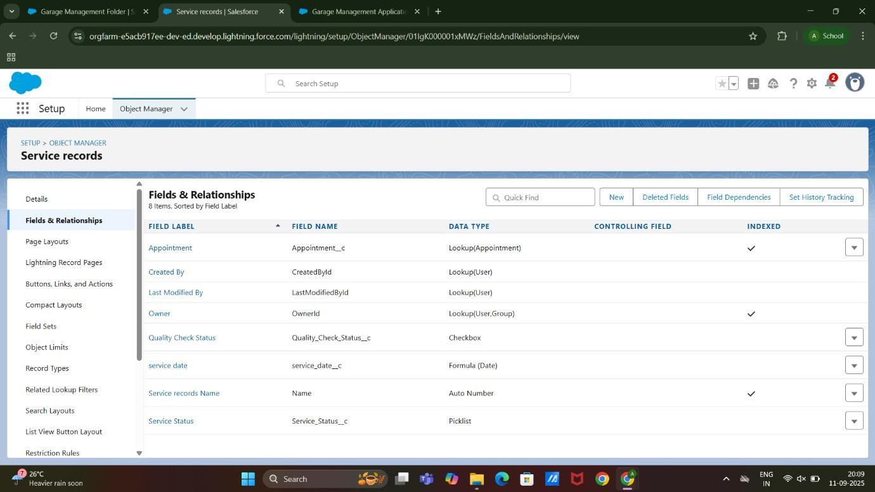

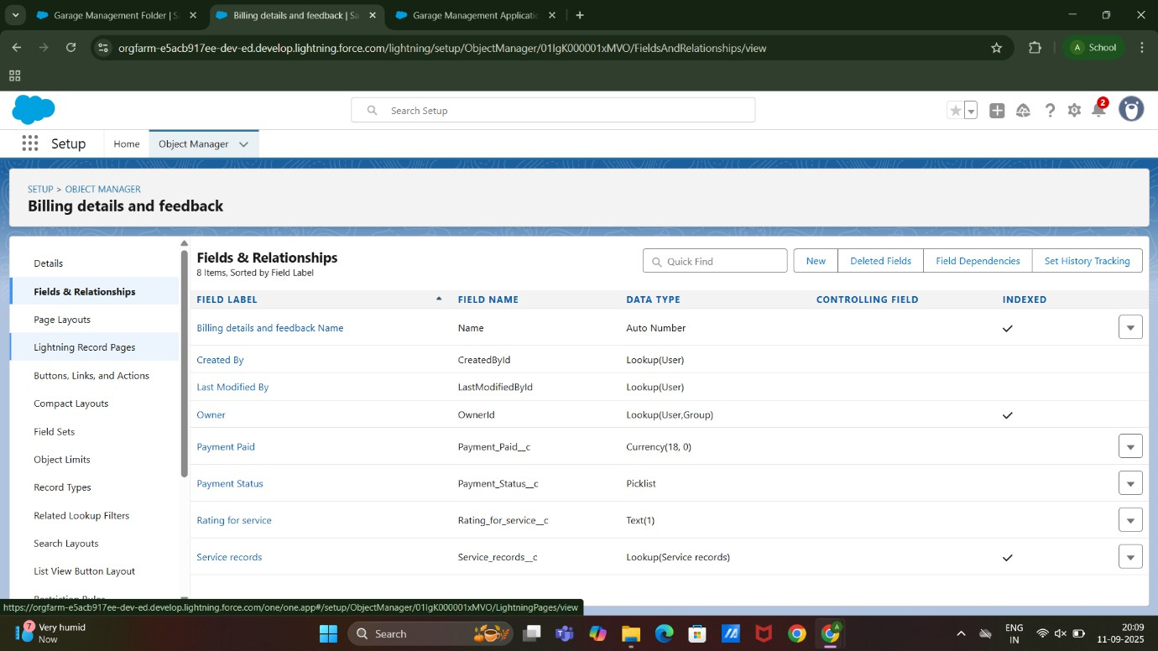

* Created Validation Rule : Appointment Object and Billing Details and Feedback Object

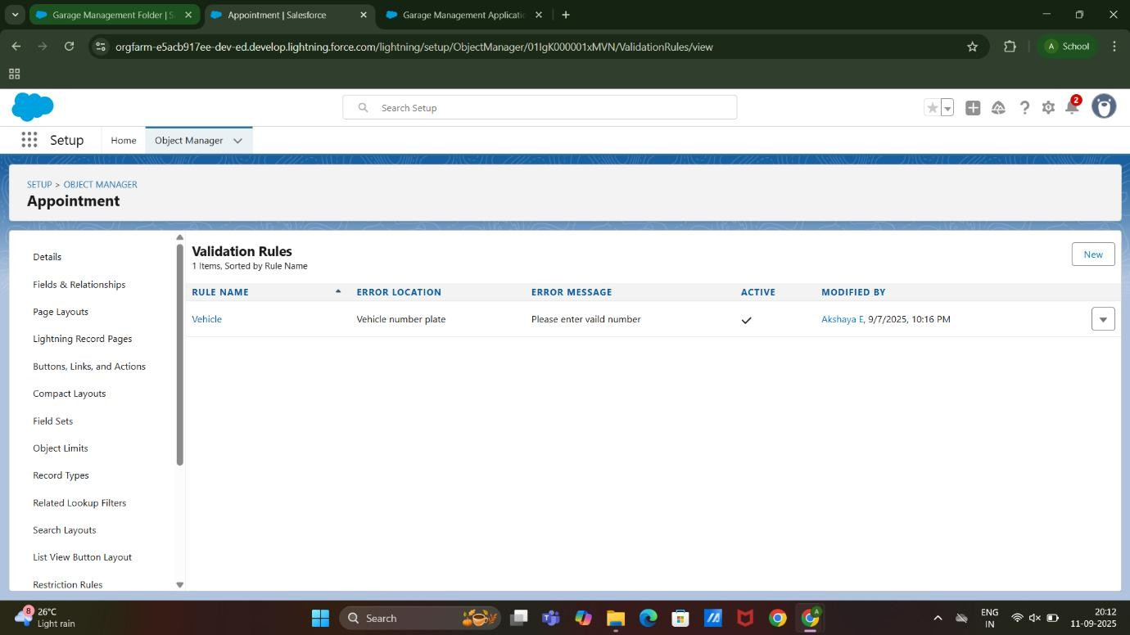

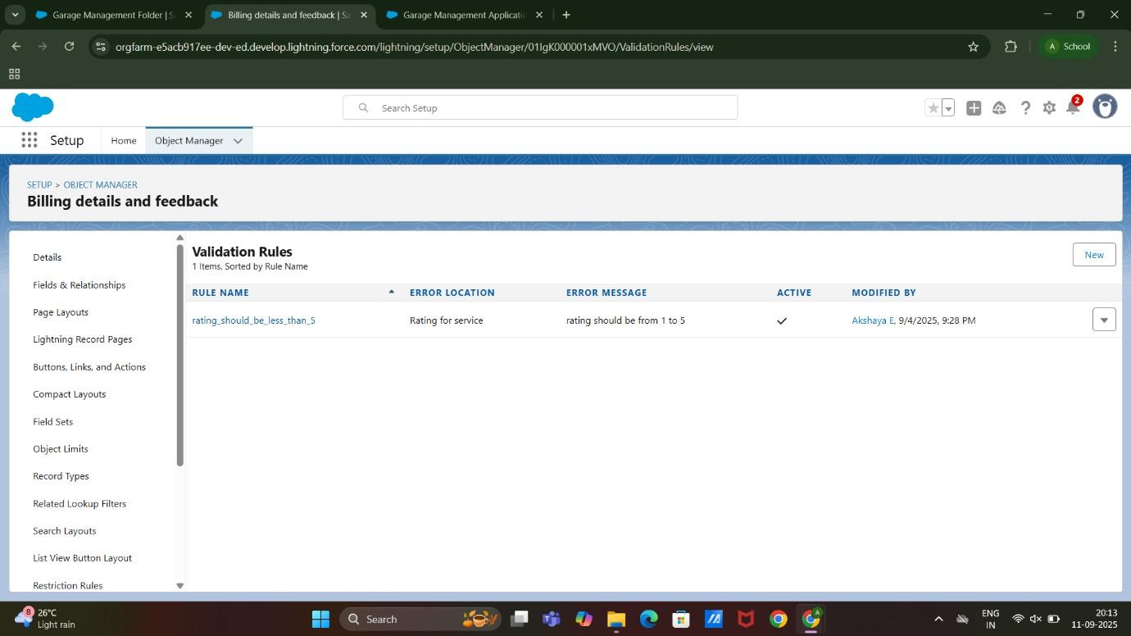

* Created Duplicate Rule : Matching rule to an Customer details Object And Duplicate rule to an Customer details Object

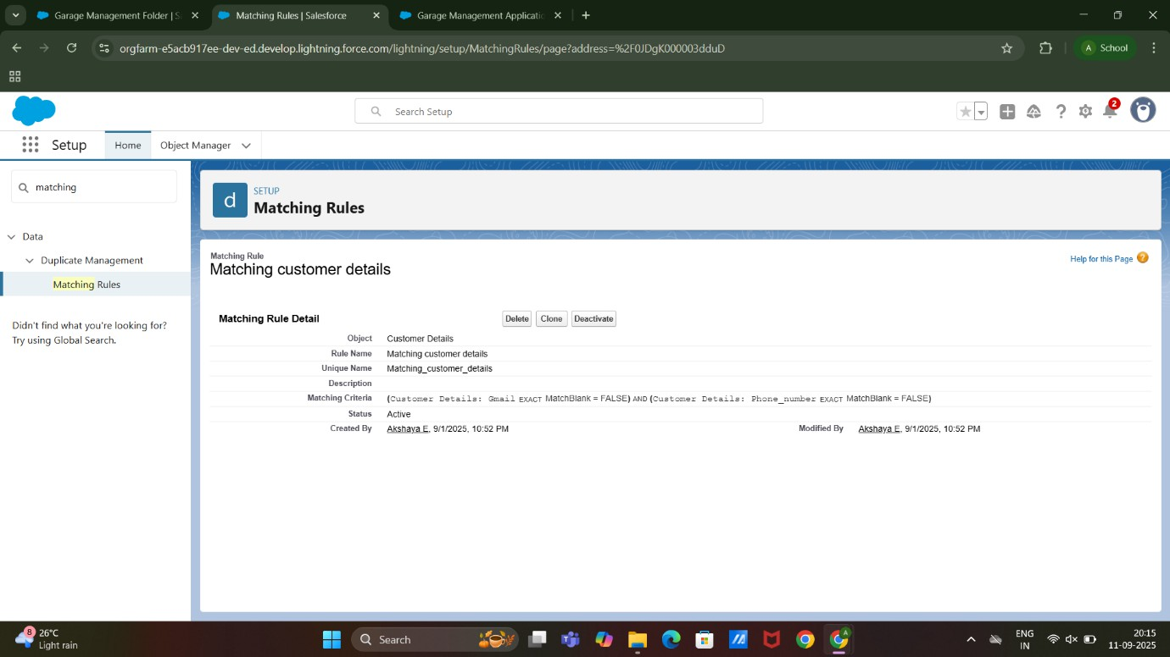

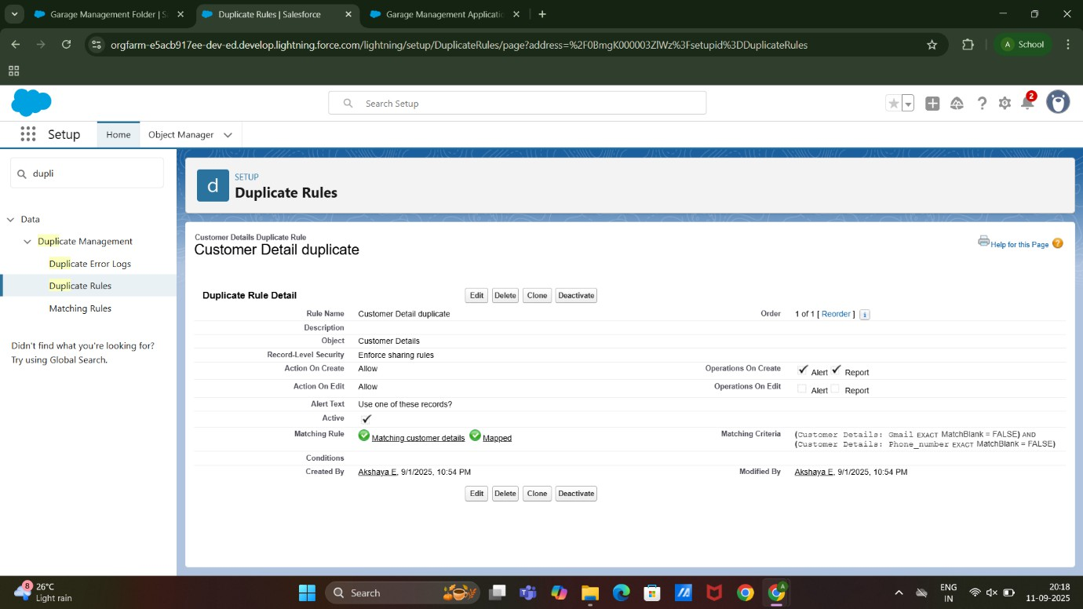

* Profiles : Manager Profile and Sales Person Profile

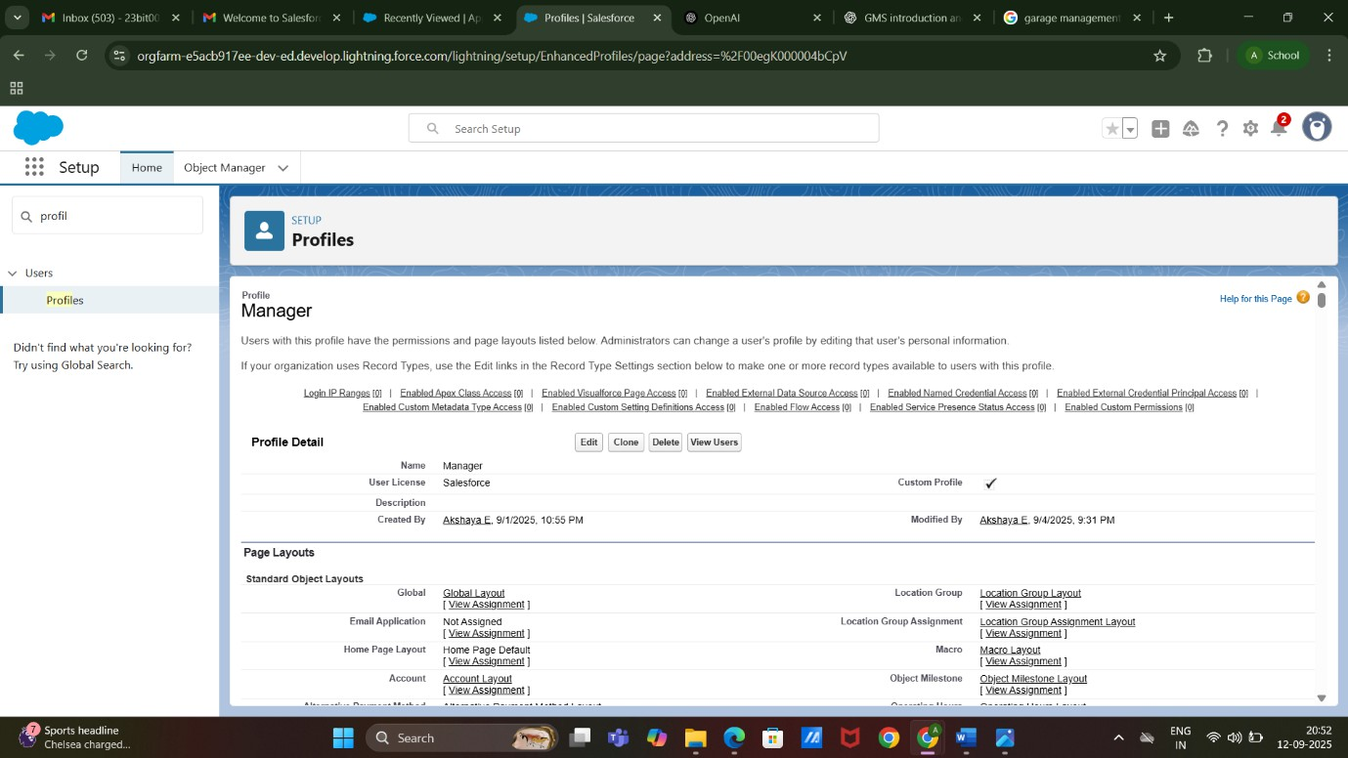

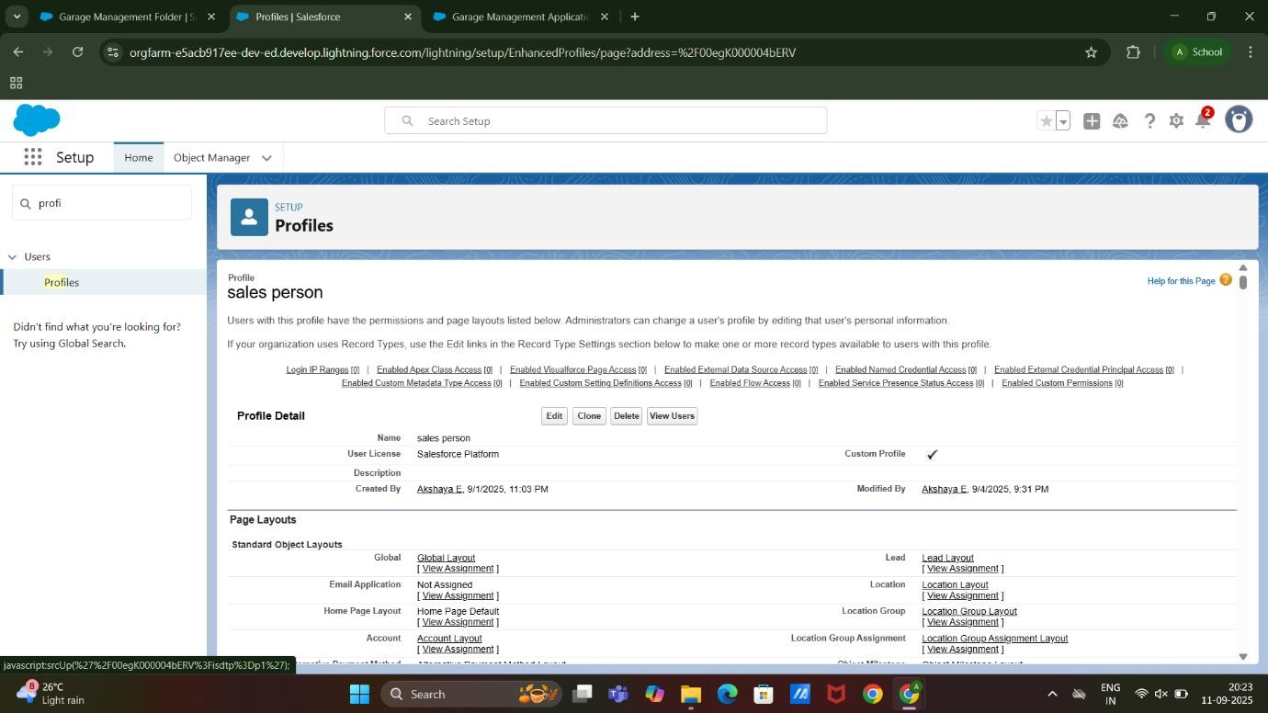

* Created Roles and Role Hierarchy: Manager and Another Role

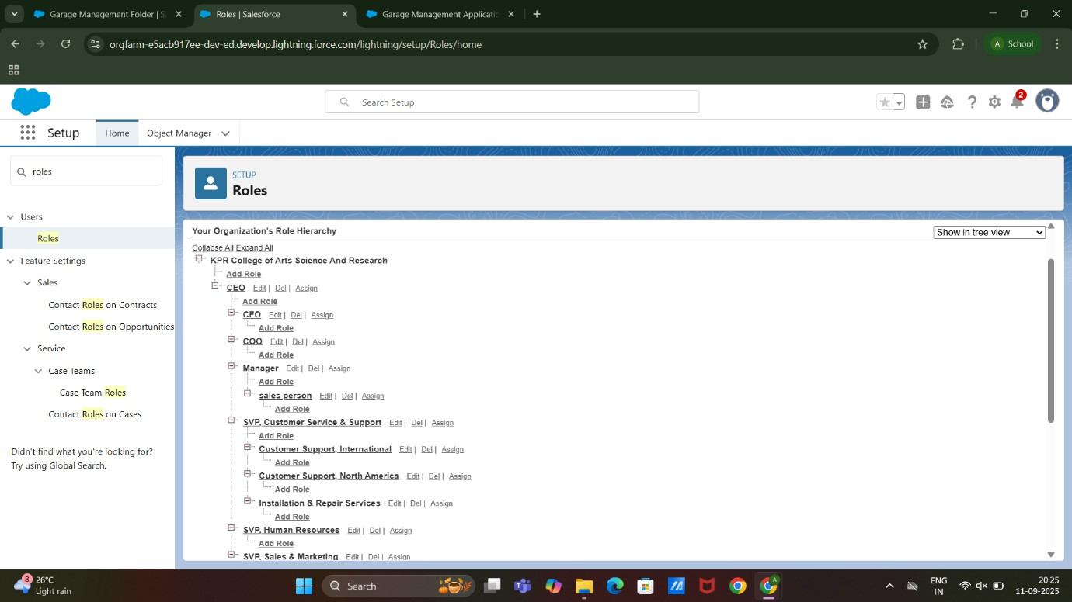

* Created User and Another User

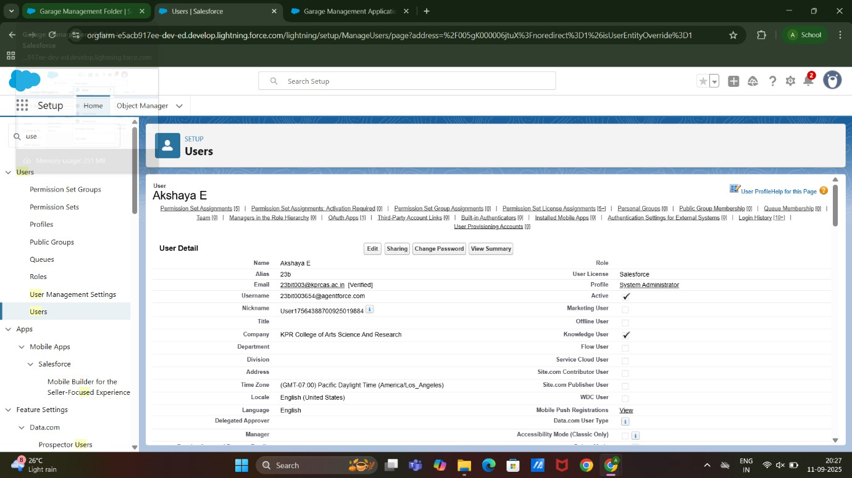

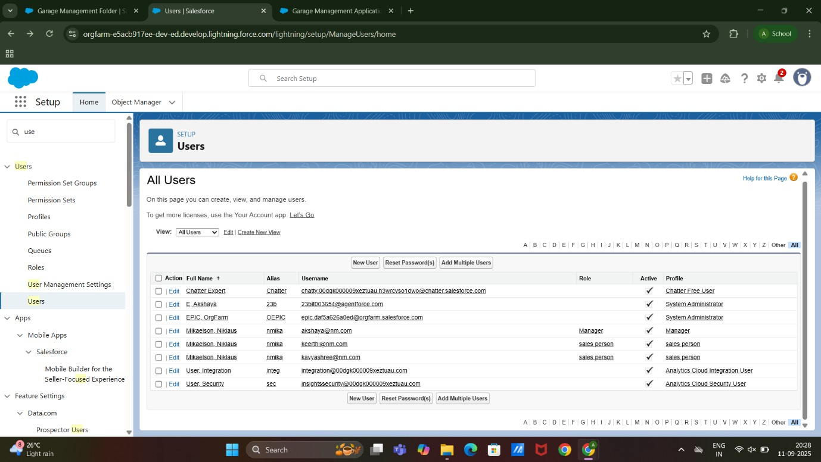

* Created New Publiuc Group

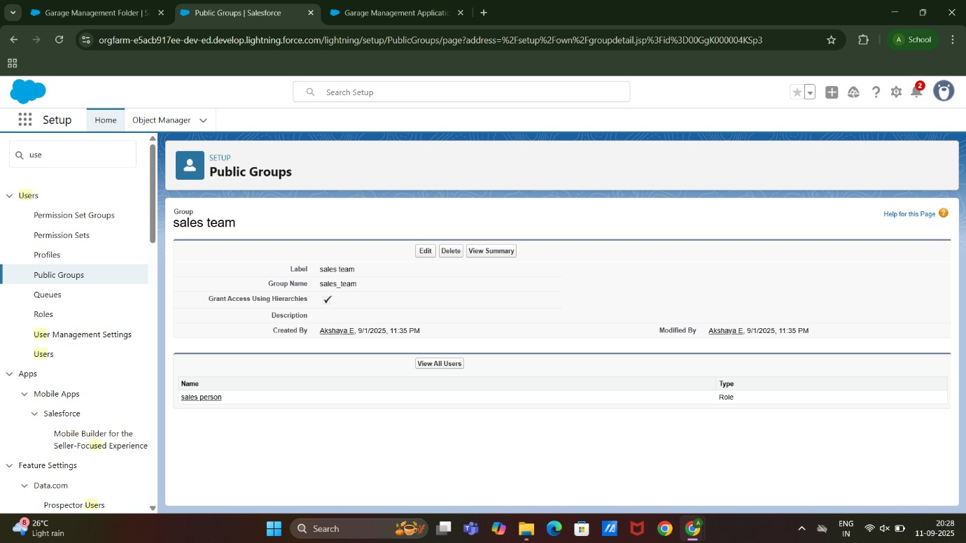

* Created Sharing Seetings

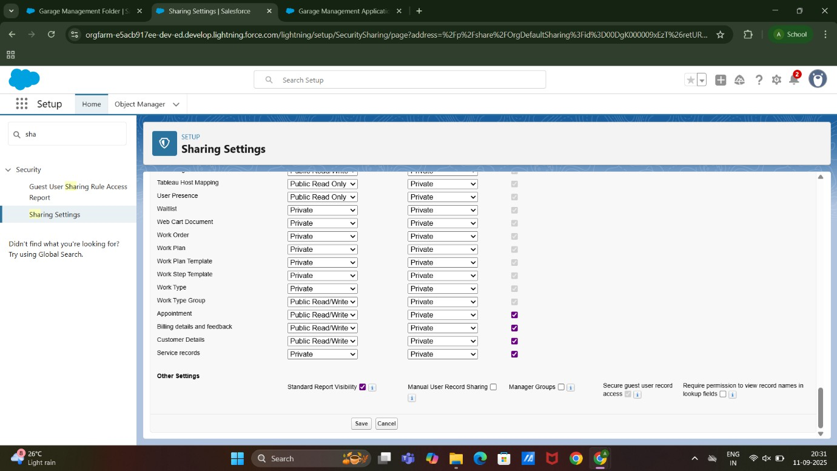

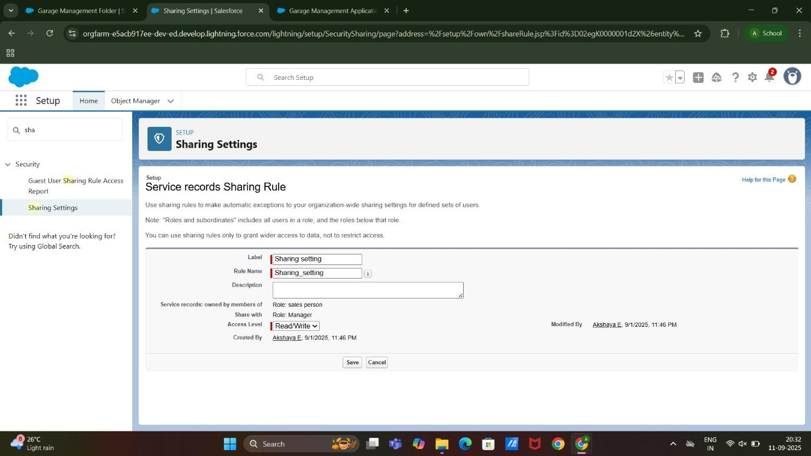

* Created A Flow and Another Flow

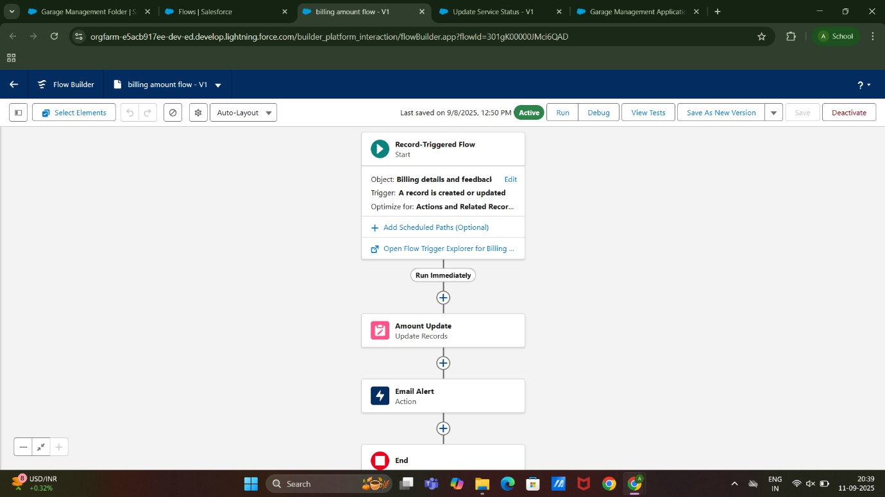

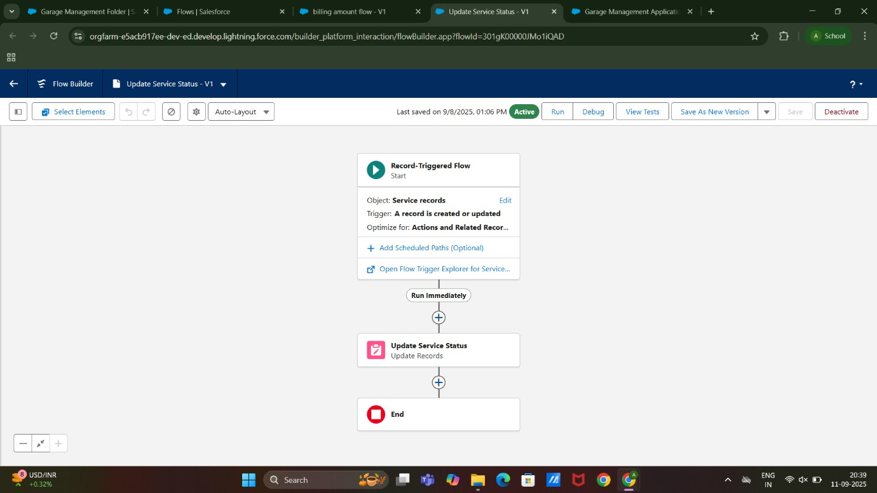

* Appex Trigger : Appex Handler

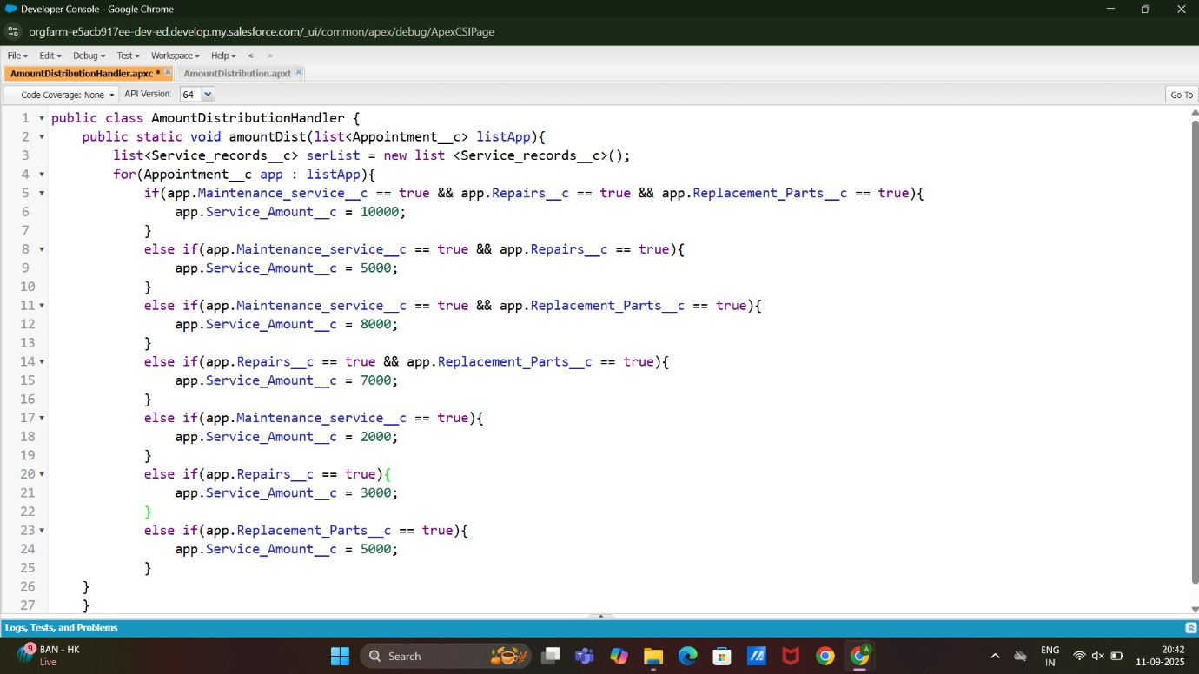

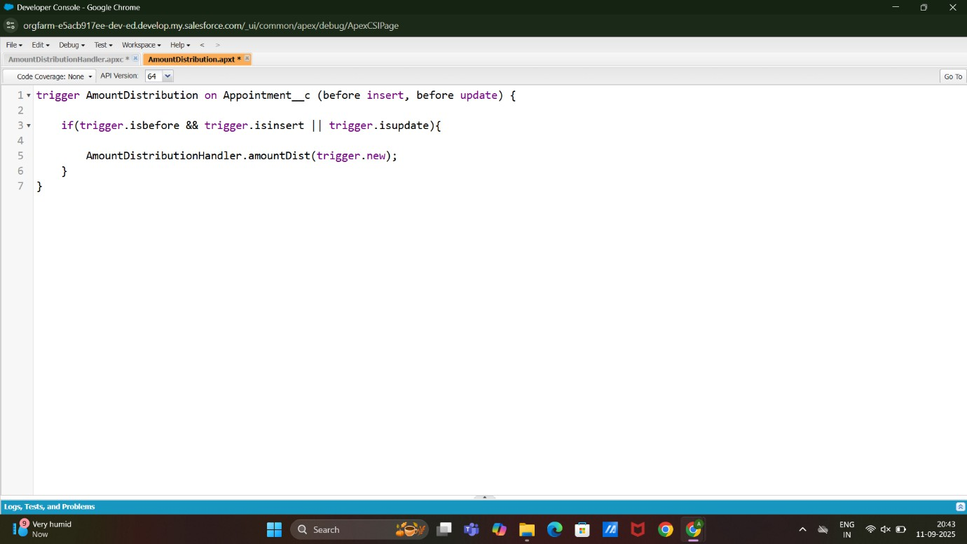

* Created Reports : Create a report, Share a report and Create report type

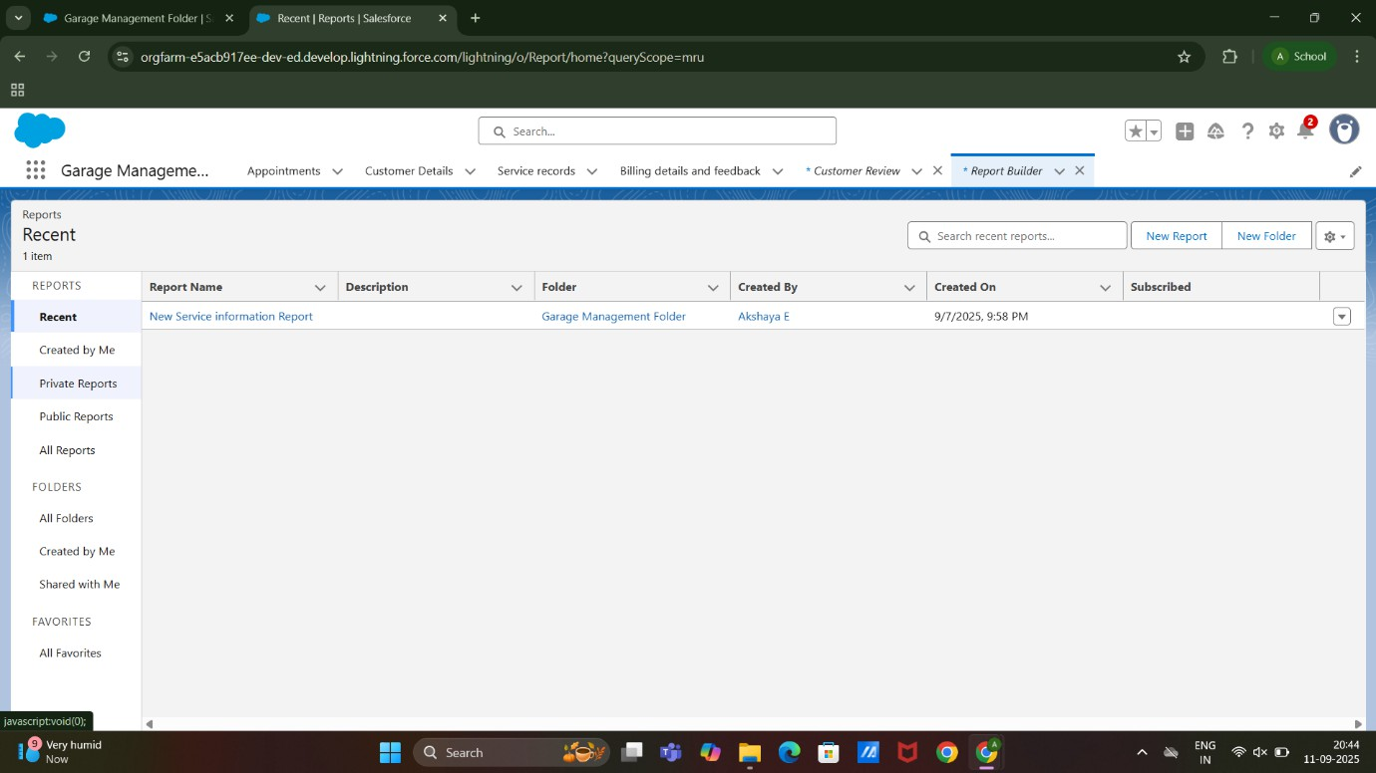

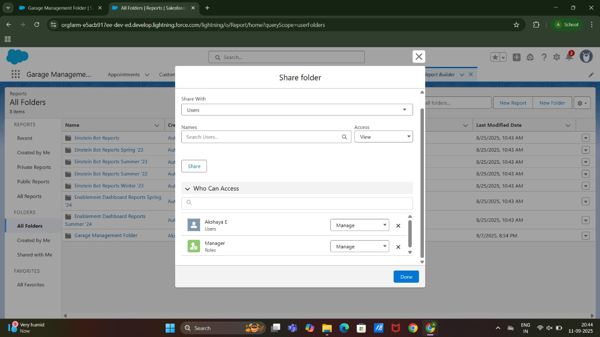

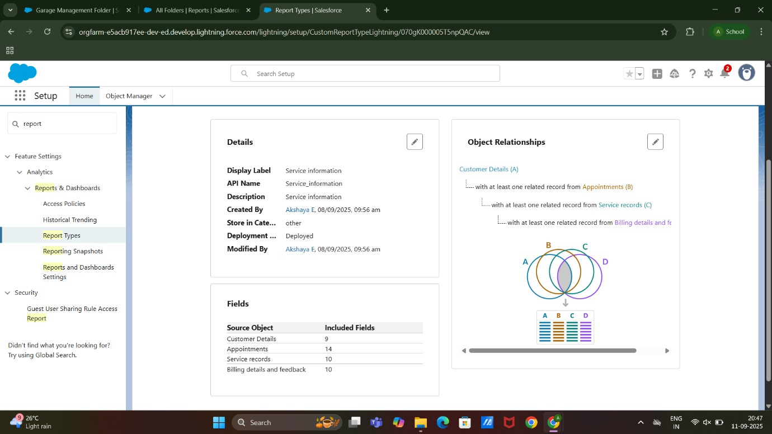

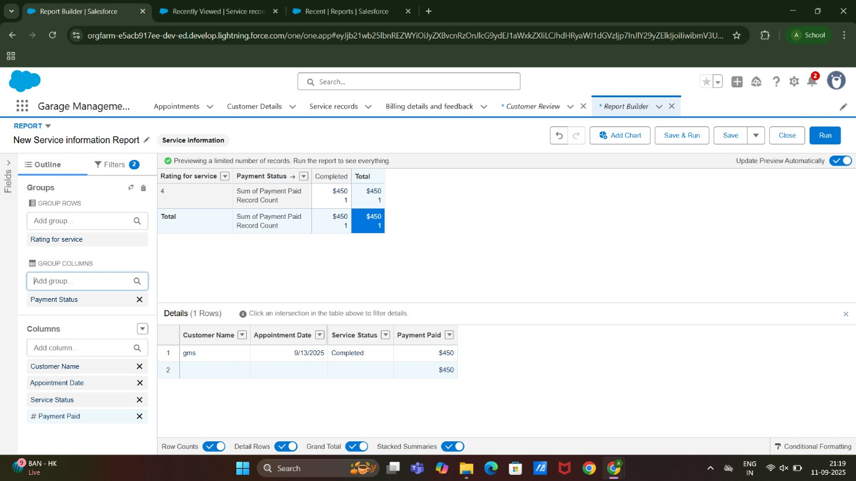

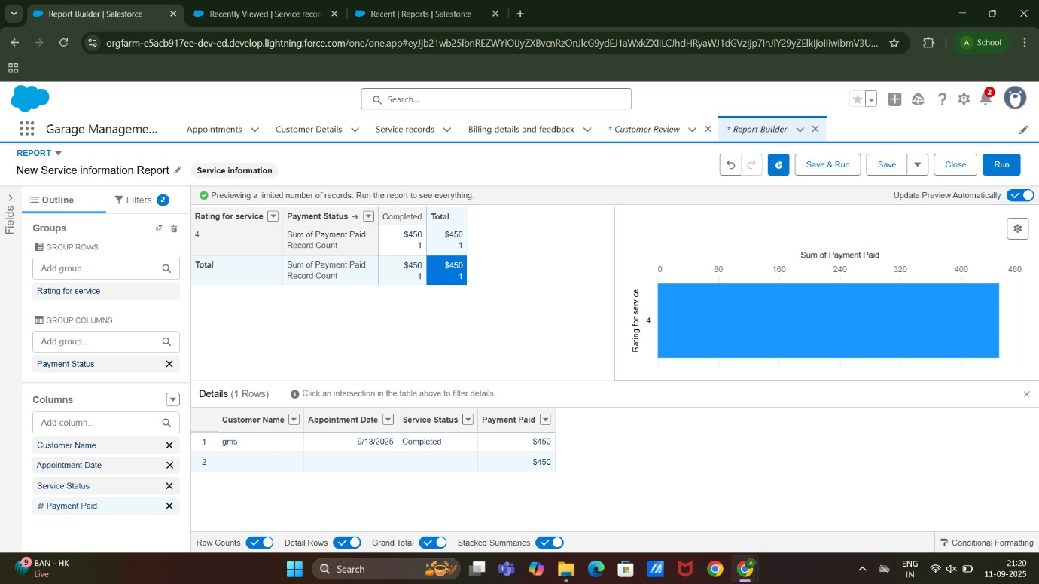

* Created Dashboard Folder and Dashboard

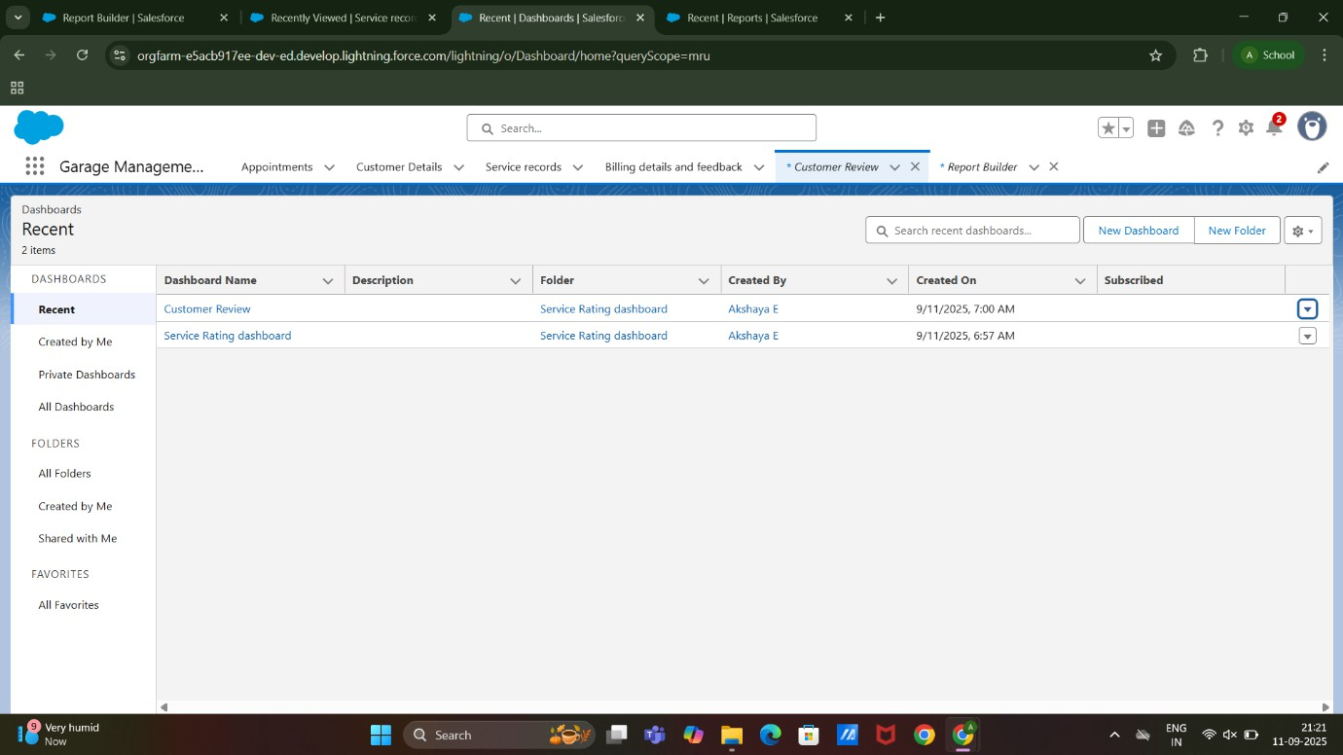

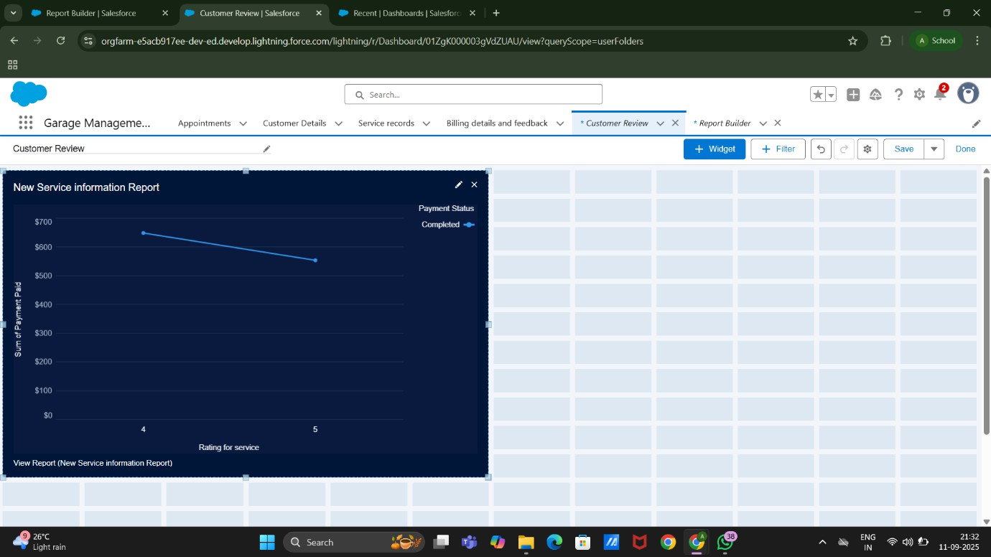

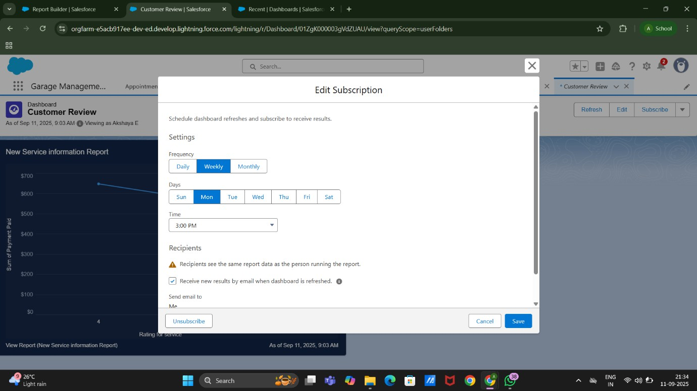

* Created User Adoption Records

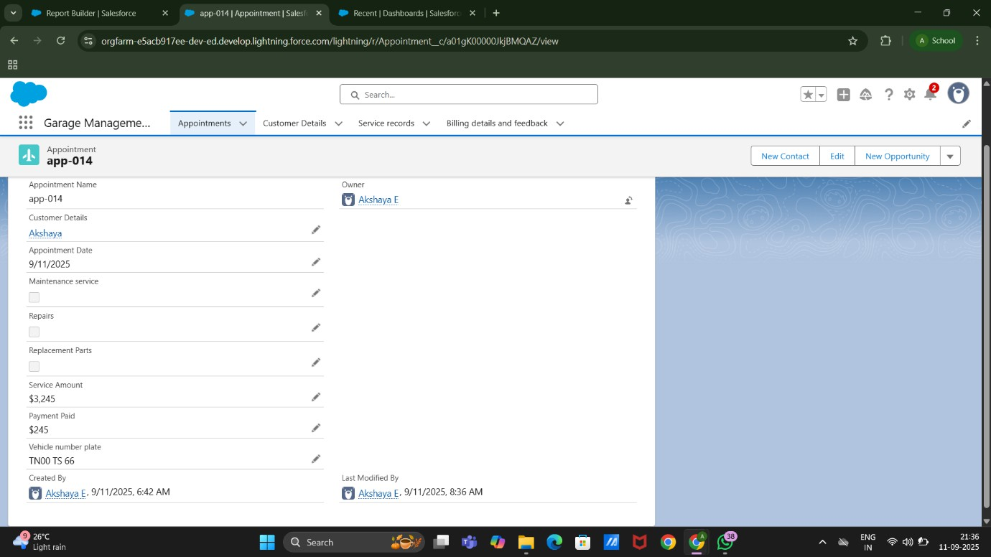

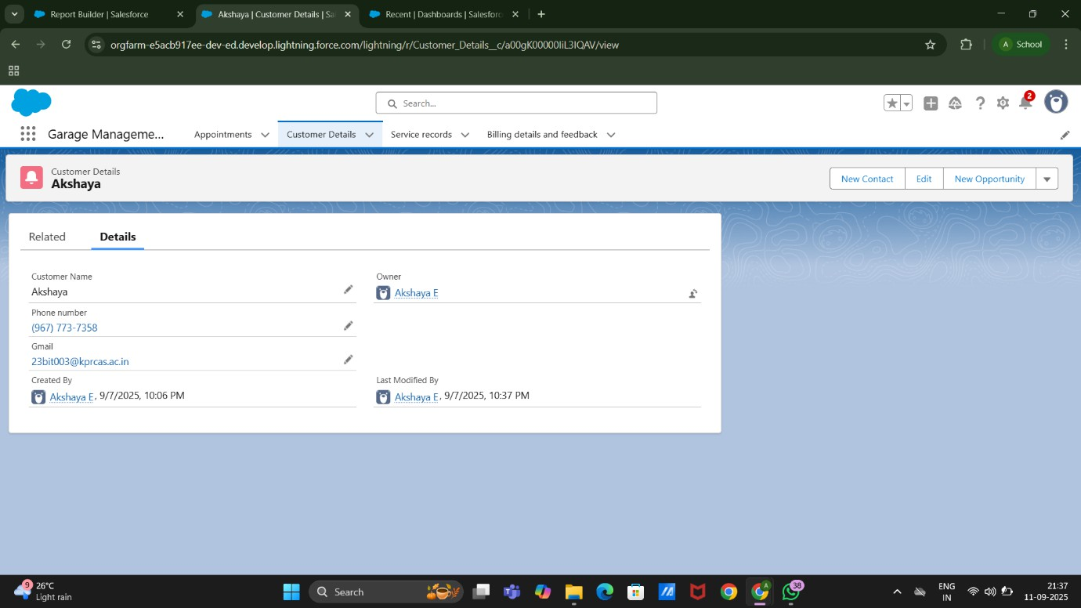

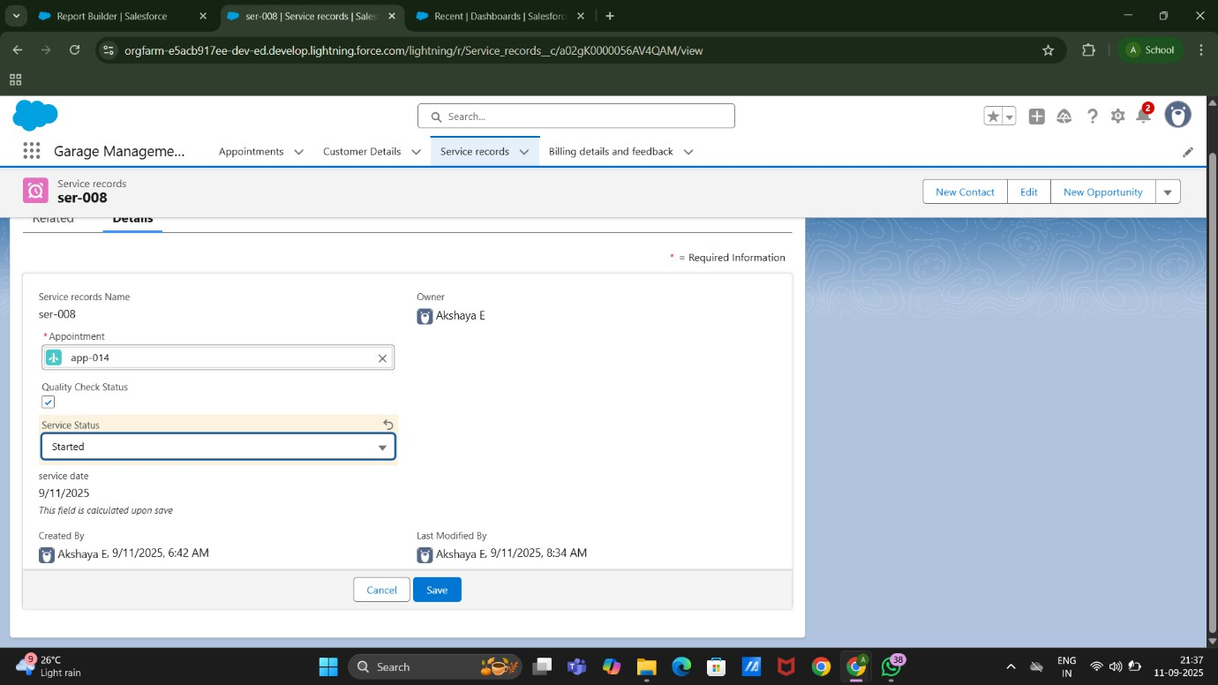

# OUTPUT:

* + Tabs for Customer Details, Appointment, Service Records and Billing Details and Feedback



* + Flows



* + New Service Information Reports





## Advantage and Disadvantage

### Advantages of Garage Management System

1. **Improved Efficiency** – Automates daily operations such as job scheduling, invoicing, and inventory tracking, reducing manual workload.
2. **Better Customer Experience** – Provides online booking, service reminders, and real- time updates on vehicle status.
3. **Accurate Record Keeping** – Maintains complete service history, bills, and reports, helping with both customer reference and compliance.
4. **Time & Cost Savings** – Minimizes delays, reduces paperwork, and optimizes resource allocation.
5. **Inventory Management** – Tracks spare parts, stock levels, and orders to prevent shortages or overstock.
6. **Data-Driven Insights** – Generates reports on revenue, expenses, and performance, enabling better decision-making.
7. **Transparency & Trust** – Customers can see service progress, cost estimates, and final bills clearly, reducing disputes.
8. **Scalability** – Can be adapted for small garages or larger service centers as the business grows.
9. **Reduced Errors** – Automated calculations in billing and inventory help minimize human mistakes.
10. **Enhanced Communication** – Improves coordination between staff, technicians, and customers.

### Disadvantages of Garage Management System

1. **Initial Cost** – Purchasing and implementing GMS software can be expensive for small garages.
2. **Training Requirement** – Staff may need time and training to get used to the system.
3. **Dependence on Technology** – If the system crashes or faces downtime, it can disrupt operations.
4. **Data Security Risks** – Customer and financial data may be vulnerable to cyber threats if security is weak.
5. **Internet Dependency** – Cloud-based GMS requires stable internet; poor connectivity can cause delays.
6. **Customization Limits** – Some off-the-shelf GMS solutions may not meet the unique needs of every garage.
7. **Maintenance Costs** – Regular updates, technical support, or subscription fees may add to expenses.
8. **Resistance to Change** – Older staff or traditional garages may hesitate to shift from manual processes.
9. **Integration Challenges** – May not easily integrate with existing accounting, CRM, or ERP systems.
10. **Over-Reliance on System** – If staff become too dependent, basic manual processes may be forgotten.

## Conclusion

The Garage Management System is a powerful tool that bridges the gap between operational efficiency and customer satisfaction in the automotive repair industry. By streamlining processes such as scheduling, billing, inventory control, and customer

communication, it enables garages to operate more productively and deliver a superior service experience.

While GMS offers numerous advantages—including efficiency, transparency, and data-driven decision-making—it also comes with challenges like cost, training, and dependence on technology. However, when implemented effectively, the benefits far outweigh the

drawbacks, making it a valuable investment for garages of all sizes.

In today’s competitive market, adopting a Garage Management System is not just a technological upgrade—it is a strategic step toward long-term growth, customer loyalty, and business success.

## Apex Handler

### AmountDistributionHandler: Source Code:

public class AmountDistributionHandler

{

public static void amountDist(list<Appointment c> listApp){

list<Service_records c> serList = new list <Service_records c>(); for(Appointment c app : listApp){

if(app.Maintenance_service c == true && app.Repairs c == true && app.Replacement_Parts c == true){

app.Service_Amount c = 10000;

}

else if(app.Maintenance_service c == true && app.Repairs c == true){ app.Service_Amount c = 5000;

}

else if(app.Maintenance_service c == true && app.Replacement_Parts c == true){ app.Service_Amount c = 8000;

}

else if(app.Repairs c == true && app.Replacement_Parts c == true){ app.Service_Amount c = 7000;

}

else if(app.Maintenance_service c == true){ app.Service_Amount c = 2000;

}

else if(app.Repairs c == true){ app.Service_Amount c = 3000;

}

else if(app.Replacement_Parts c == true){ app.Service_Amount c = 5000;

}

}

}

}

### Trigger:

**Source Code:**

trigger AmountDistribution on Appointment c (before insert, before update)

{

if(trigger.isbefore && trigger.isinsert || trigger.isupdate)

{

AmountDistributionHandler.amountDist(trigger.new);

}

}